Department of Accounts

Small Purchase
Charge Card Administration (CCA)



CCA Forms Application
User’s Guide

March 2017

Table of Contents

Overview 1
CCA Forms System - User Security 3
Accessing the CCA Forms System 4
Forgot Logon ID 12
Forgot Password 13
Broadcast Messages 18
Main Menu 19
Personal Options Page 20
Contact Us 22
CCA Agency Forms 23
View/Print Agency CCA Forms 31

Overview

Introduction | DOA has developed a web-based system that allows agency Charge Card Program Administrators to request action from DOA as it relates to Small Purchase Charge Cards. Users can access the system at https://cca.doa.virginia.gov/Login.cfm or through DOA’s home page.  The Charge Card Administration Forms Application has been designed to be as user-friendly as possible and requires little intervention from outside resources. However, DOA realizes there may be some functions individuals may need assistance with and has developed this Guide to aid agency personnel.

Charge Card Administration Forms Features | The Charge Card Administration – Forms Application provides Commonwealth of Virginia agency personnel the means to:  - Fill out automated forms for certain actions from the Charge Card Administration personnel at DOA.  - Store electronic versions of the forms for future inquiry.  - Ability to monitor the processing of your forms.  - Ability to print forms in PDF format.  - Built-in Help pages included in the Charge Card Administration Form Application.

Continued on next page
Overview, Continued

Database Security | State-of-the-art security features are provided to maintain confidentiality of report information.  - Application Security - requires a Logon ID and password for system access. Individuals will be required to keep this information confidential to provide the utmost security to the Commonwealth’s data.  - Secure Socket Layer - SSL - uses a 128-bit encryption routine to protect the data as it travels back and forth over the Internet.  - Encrypted File System - EFS - is an operating system feature that protects sensitive data and prevents unauthorized access to the file directory.

Access Requirements | - Browser must be enabled for Java Script.  - Browser must be enabled for Cookies.  - Browser must be enabled for Secure Socket Layer (SSL) Security (128-bit version).  - If connecting to the site from behind a firewall or proxy server, it must allow SSL (port 443) communication.  - Internet Explorer browser, version 4.0 or higher.  - Designed to be viewed at a screen resolution of 800 by 600 or greater, with a minimum of 256 colors.  - Connection speed of 56k modem (or higher) is highly recommended.

Web Address | https://cca.doa.virginia.gov/Login.cfm

CCA Forms System - User Security

Security Levels | Charge Card Administration System has two levels of application security.  - Systems Administrator - DOA application specific personnel who establish individual agency Charge Card Administration User security.  - Individual User - Agency personnel that use the Charge Card Administration system to access, request, certify, and/or view their Charge Card Forms data.

Individual User | An agency is required to identify at least one Charge Card Administration Individual User. The Charge Card Administration’s (CCA) Individual Users are responsible for completing the CCA form via the web application. Security access for CCA individual user are set up via the automated Security record set up process.

Accessing the CCA Forms System

Initial Logon Record Setup | To set up an initial security record, access the DOA's website at https://cca.doa.virginia.gov/Login.cfm and then select “New Security” located on the left-hand menu.

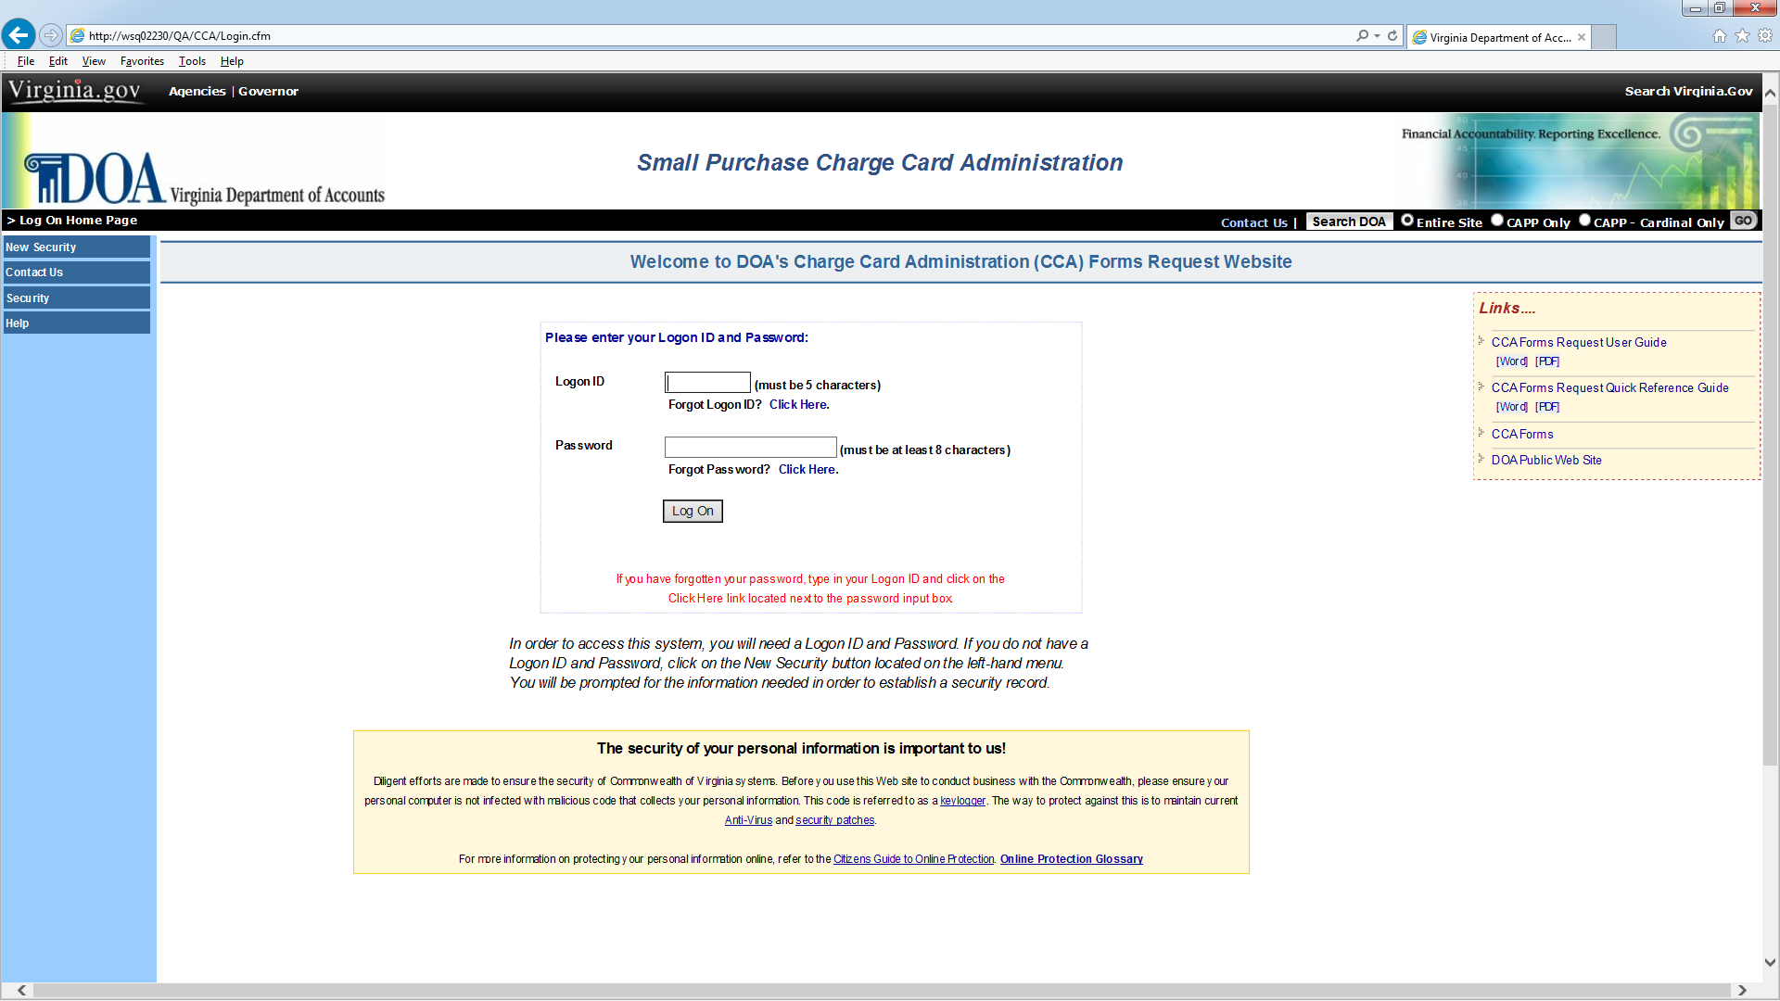

The following screen will be displayed. Enter in your agency number and email address to continue to the Security Logon Form.

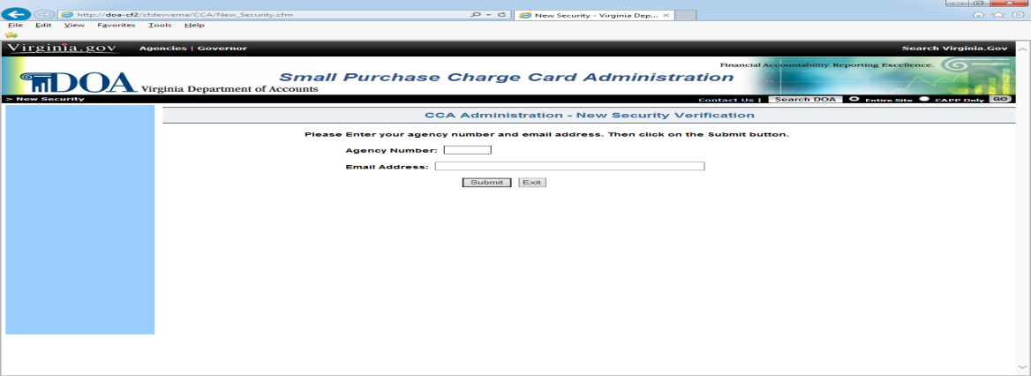

Continued on next page

Accessing the CCA Forms System, Continued

Initial Logon Record Setup (Cont.) | If your agency number and email address matches DOA’s database information, then the following screen will be displayed. Follow the instructions on the screen to complete the Security Record Logon Form.

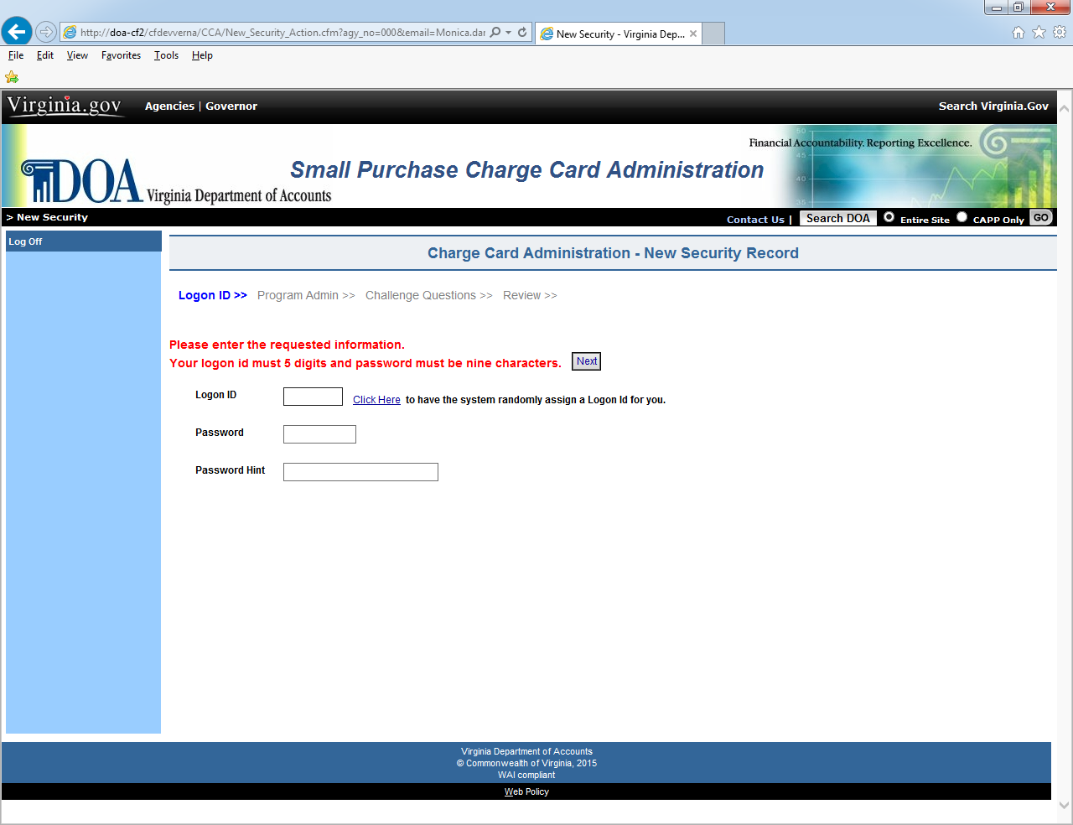

Continued on next page

Accessing the CCA Forms System, Continued

Initial Logon Record Setup (Cont.) | If the Security Record Logon Form is correctly filled out, the following screen will display the message “Your Logon Security has been successfully created”. Select the “Continue” button to access the system.

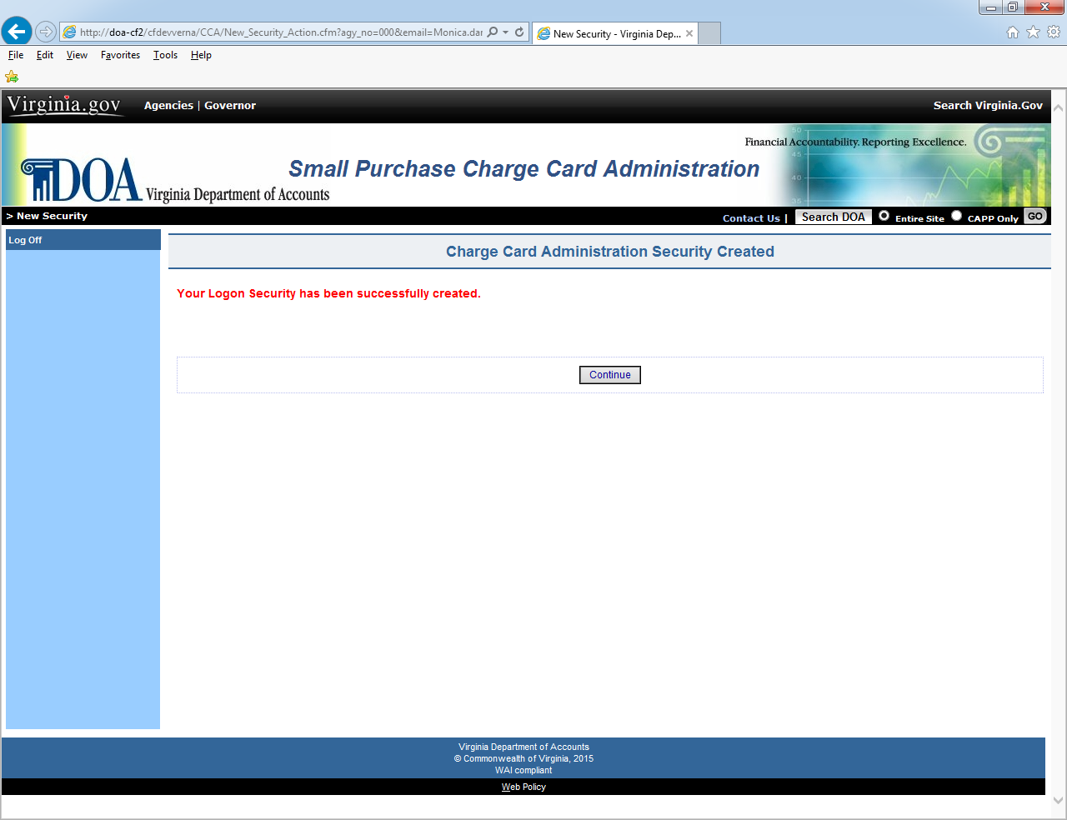

Continued on next page

Accessing the CCA Forms System, Continued

Acceptable Use Policy | During the initial logon process, after the user has entered a valid id and password, the “Acceptable Use Policy” page is displayed. This page is presented once during the initial logon process for the user to acknowledge that they have read DOA’s Acceptable Use Policy. Please read the information and select the box next to the “I Agree” to continue.

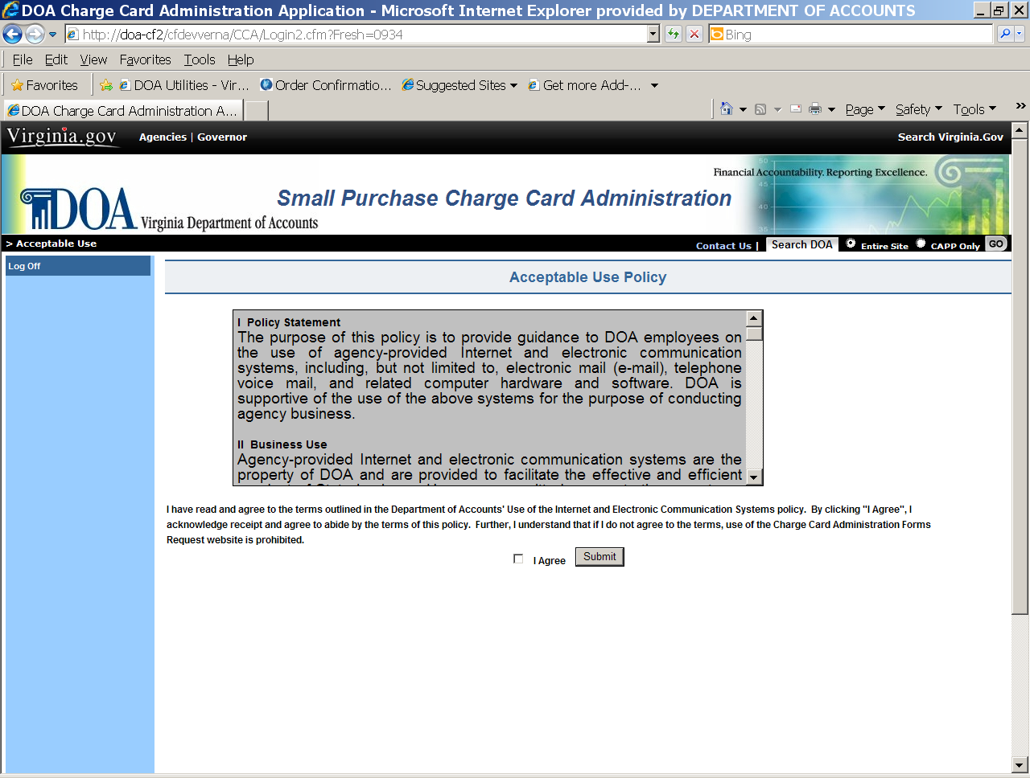

Continued on next page

Accessing the CCA Forms System, Continued

General Logon with a Valid Password | The employee enters his Logon Id and password and selects Logon button.
 |  | Step | Action
 |  | 1 | Enter Logon ID (must be five digits)
 |  | 2 | Enter the User Password (must be at least 8 characters)
 |  | 3 | Click on the Logon button.
 |  | 4 | If initial logon, click on the box next to the “I Agree” on the “Acceptable Use” page.
 |  | If a valid logon id and password are entered, the Broadcast Messages page is displayed.

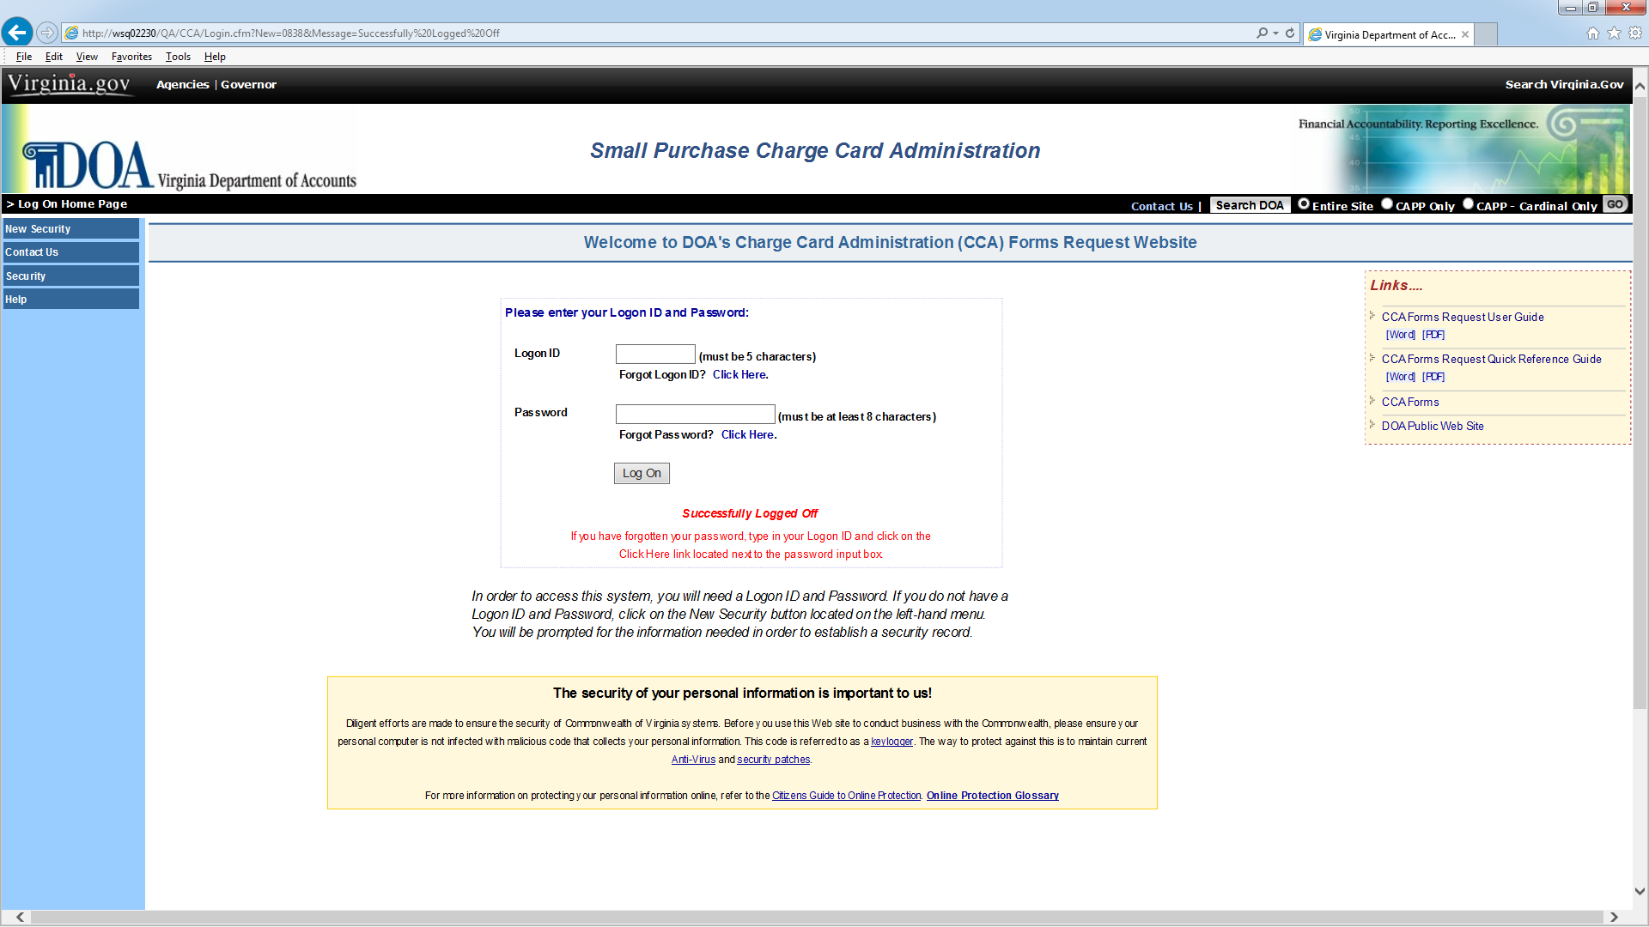

Continued on next page
Accessing the CCA Forms System, Continued

Navigation | Navigation buttons are located in the left-hand margin of the page and links the user to other Charge Card Administration (CCA) System pages or perform requested functions as described below.

BUTTON | DESCRIPTION
Log On | Initiates the logon process for CCA System with entry of a valid login and password.
Forgot Password | Links user to the Forgot Password page where user can view their previously stored hint to their previously stored password.
Contact Us | Allows the user to send an e-mail with suggestions and/or questions to DOA.
Security | Links the user to information on application security and access requirements that support the CCA System.
Help | Help buttons are located on the left-side of the menu through the website to provide assistance.

Continued on next page

Accessing the CCA Forms System, Continued

Invalid Logon Info | If an invalid Logon ID or Password is entered, the message "Invalid ID" or “Invalid Password” is displayed.

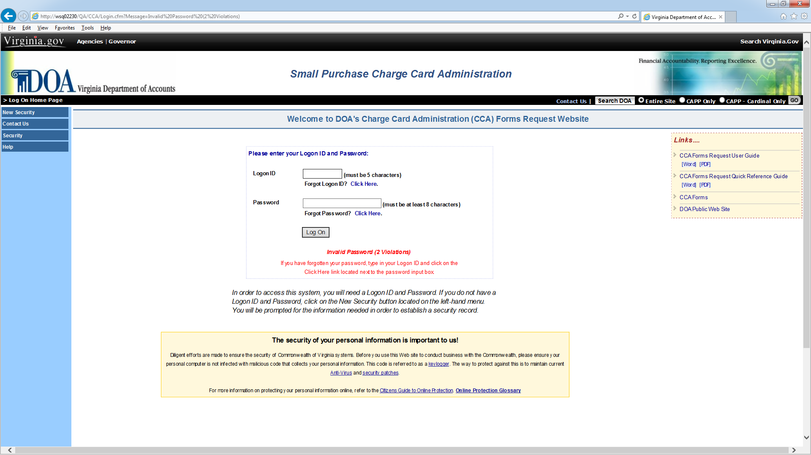

Continued on next page
Accessing the CCA Forms System, Continued

Suspended Account | After 5 (five) failed logon attempts the following message is displayed "ACCOUNT SUSPENDED DUE TO SECURITY VIOLATIONS."  Violations can only be cleared by a DOA CCA’s System Administrator. Send an email to cca@doa.virginia.gov or use the “Contact Us” link to request the violations be cleared. Alternatively, CCA System Logon violations will be cleared on the evening of each work day.

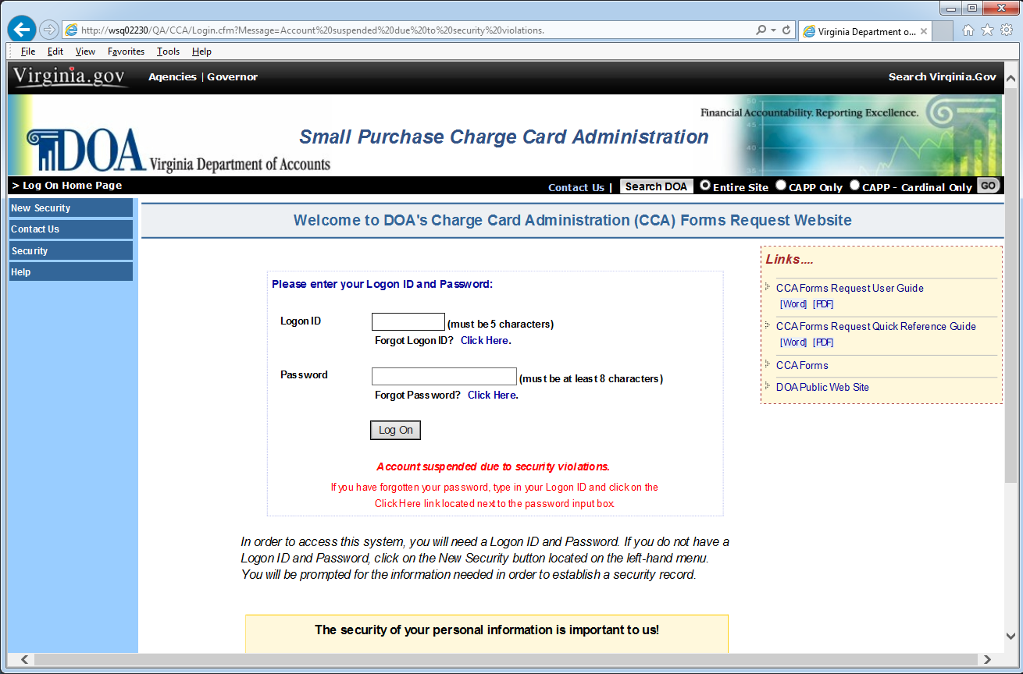

Forgot Logon ID

Forgot Logon ID | If a Charge Card Administration (CCA) System user has forgotten their five-digit logon id, click on the Forgot Logon ID link and supply the email address that you entered when you set up your initial logon id. Select the Submit button and the logon ID will be emailed to the address entered, if valid.

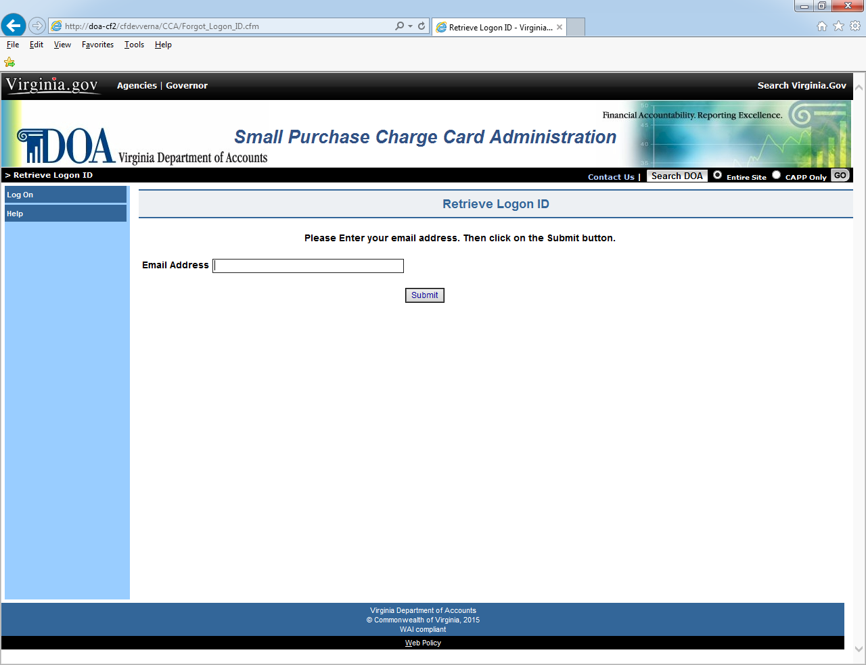

Forgot Password

Forgot Password | If a Charge Card Administration (CCA) System user has forgotten their assigned password, the user must enter their five-digit logon id and then select the Forgot Password button.  A previously stored hint will be displayed to help the user remember their password. If the hint does not help you to remember and you have selected three security questions, enter the answers to all three security questions and select the “Next” button to reset your password.

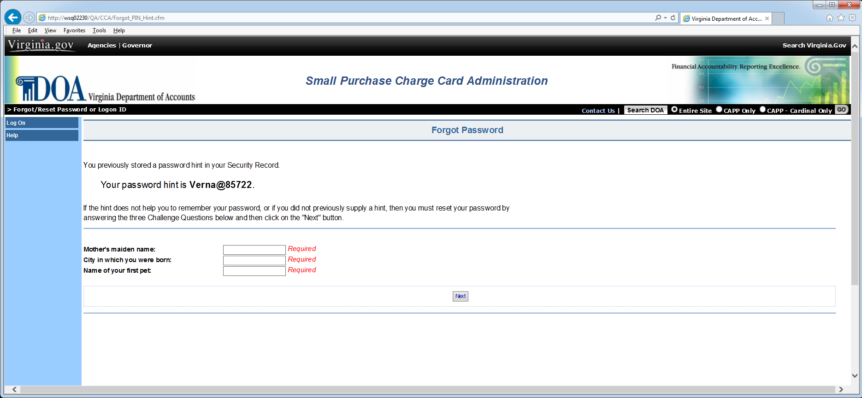

Continued on next page
Forgot Password, Continued

Forgot Password (continued) | Once you have supplied the answers to the three security questions that were previously stored in your security record, the Reset Password page is displayed.

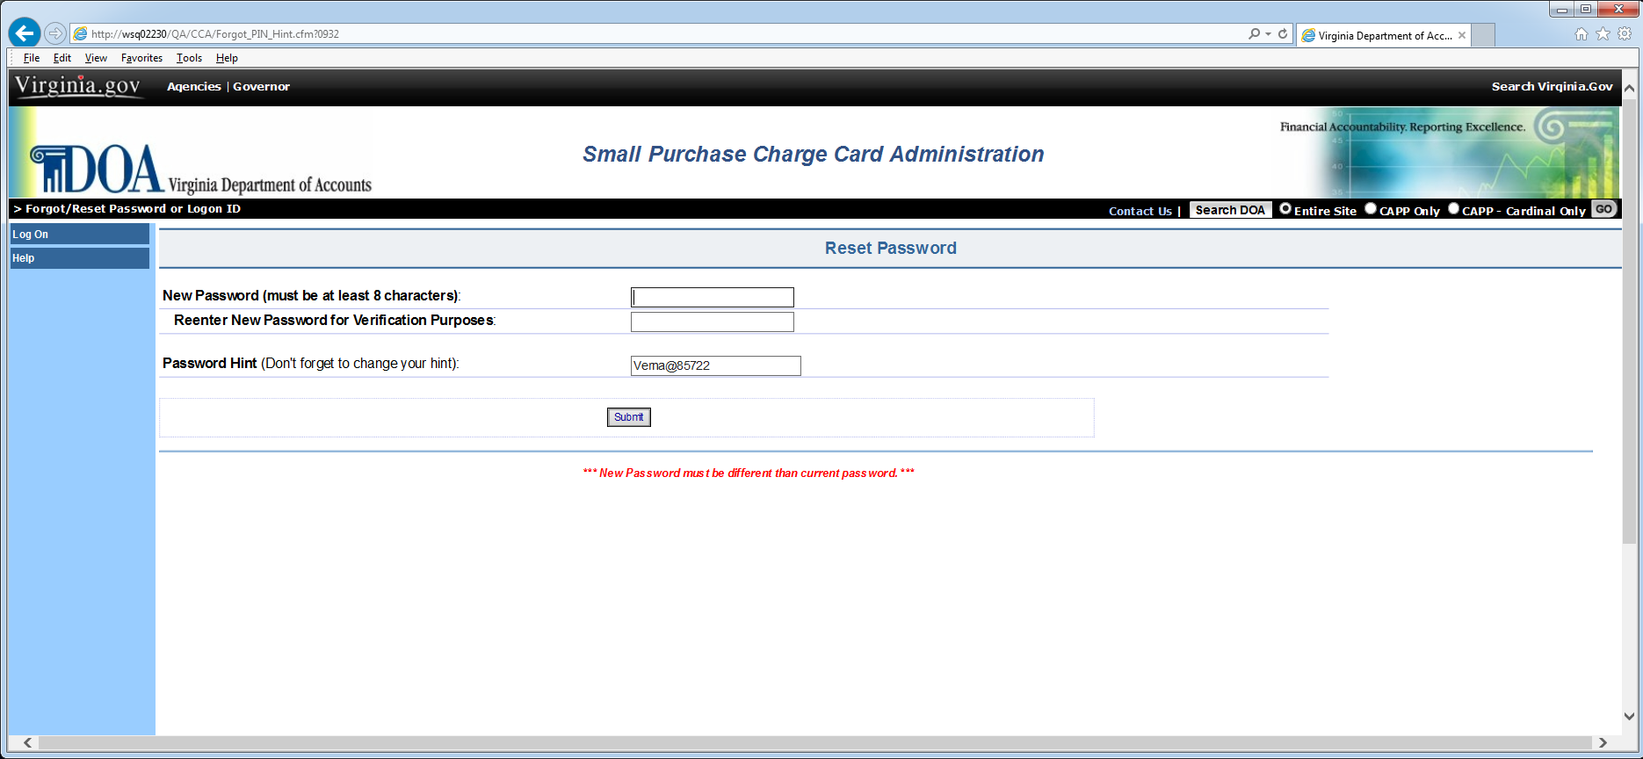

Continued on next page
Forgot Password, Continued

Forgot Password (continued) | If the hint does not help you to remember and you have not provided the answers to three security questions, you must do so and select the “Next” button in order to reset your password.
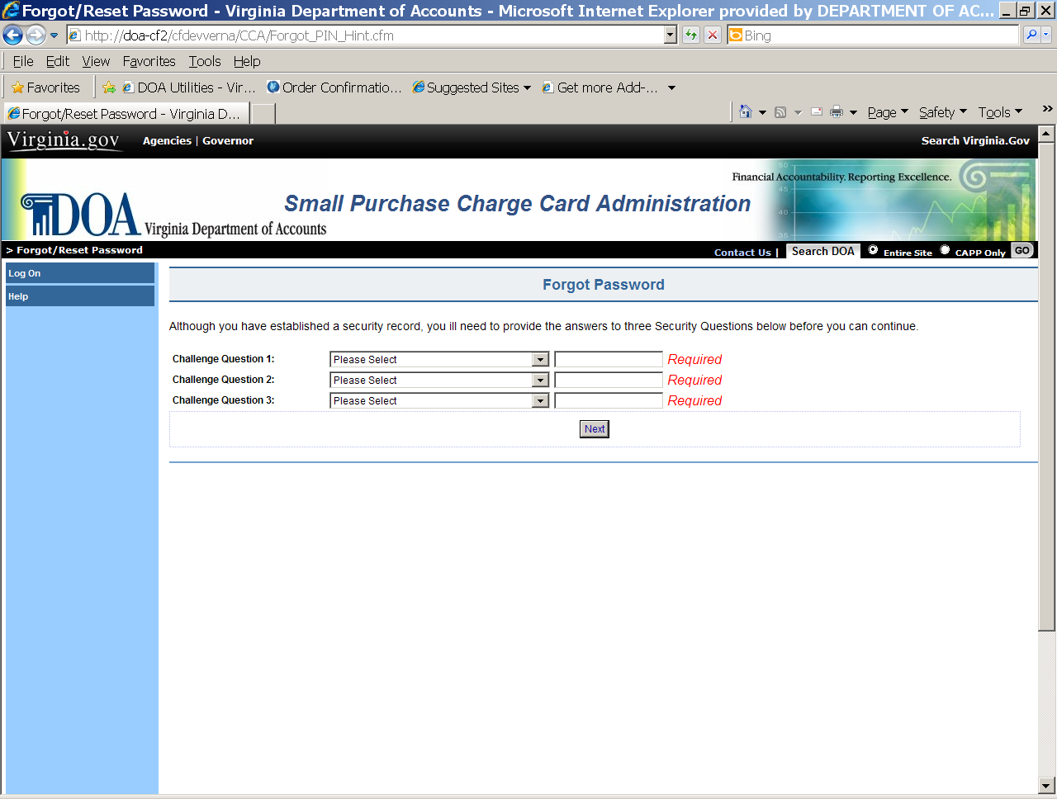

Continued on next page
Forgot Password, Continued

Password Expired/  Reset | Every 30 days your password will expire. The Password Expired/Reset page allows users to reset their passwords. The user must provide the answers to the three previously stored questions before resetting their password.

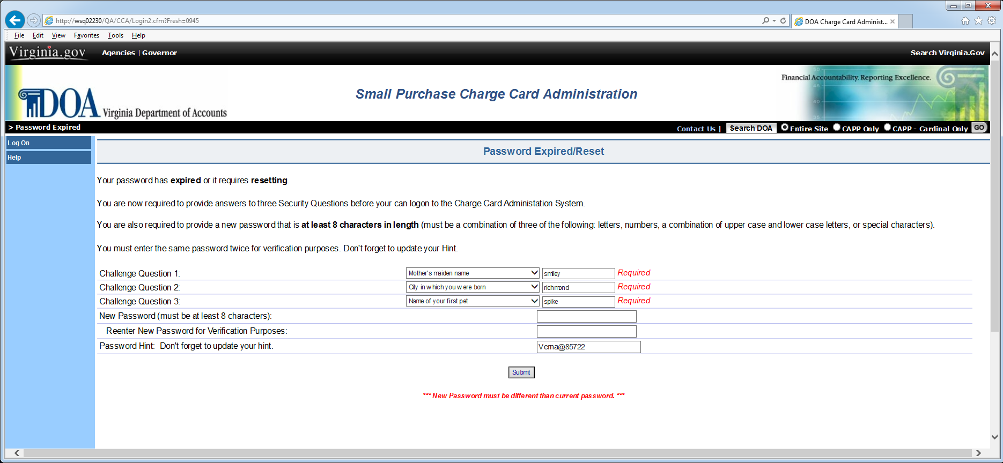

Continued on next page
Forgot Password, Continued

Password Expired/Reset (continued) | Once the user has provided the answers to the three security questions, and has entered a valid password, the user is successfully logged on to the system. Select the “Continue” button to proceed.

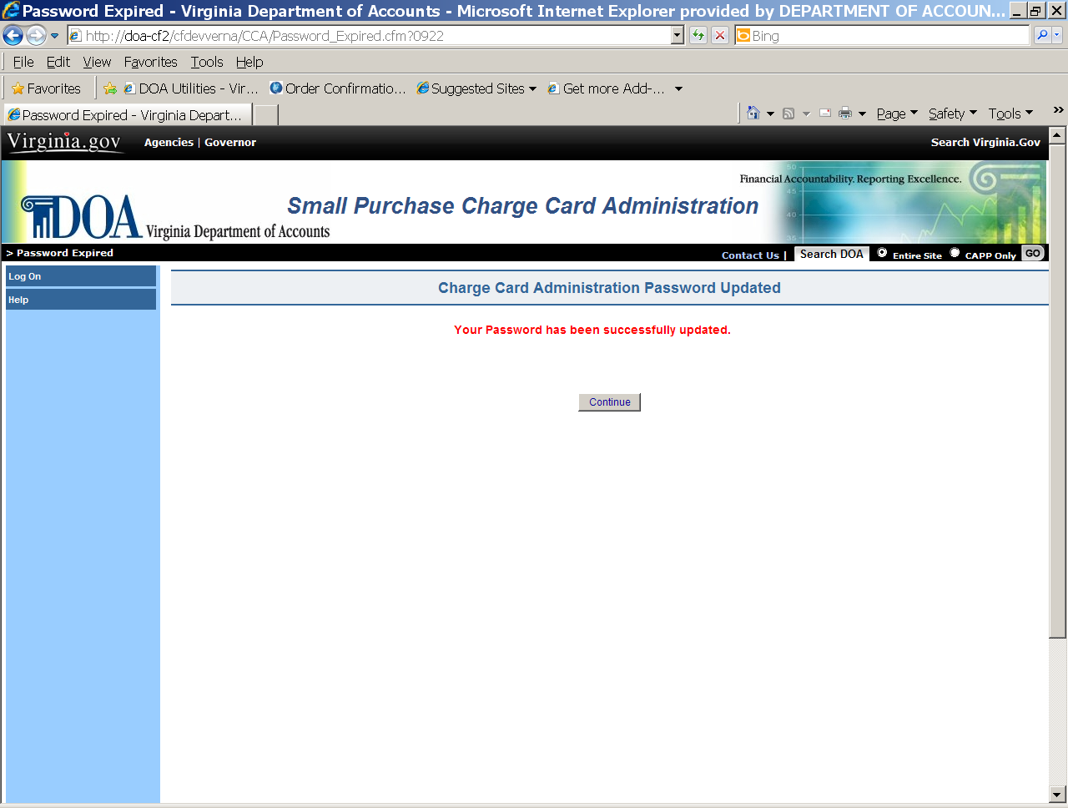

Broadcast Messages

Broadcast and Special Messages | A successful Login brings the user to the Broadcast Message page. This page is used to communicate to the user information from DOA pertaining to the Charge Card Administration system.  From Broadcast Messages you have the option to choose Main Menu. Selecting this option will take you to the main menu of the application.

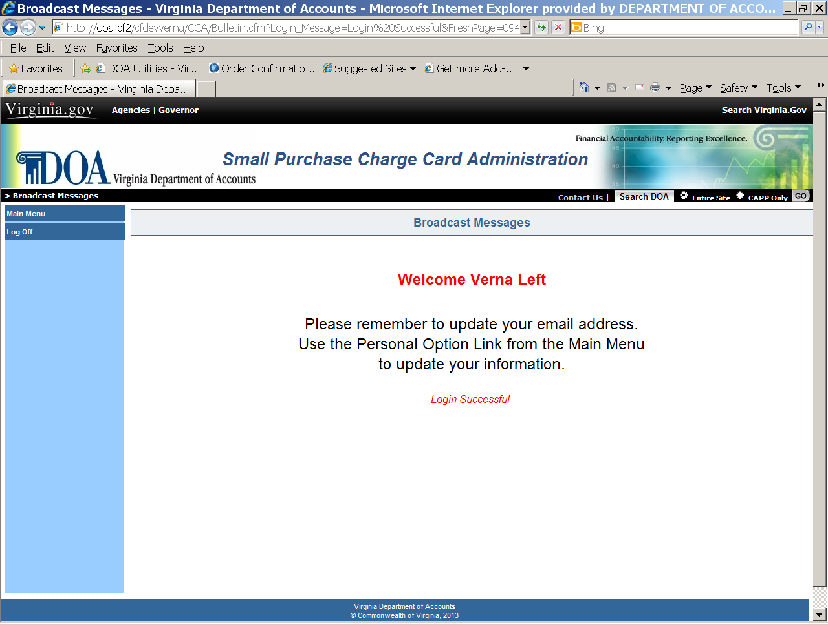

Main Menu

Main Menu Options | From the Main Menu page, select an option from the left-hand menu. Selecting the Agency Forms link will take the user to the Forms Selection Menu of Charge Card Administration System. The DOA Utilities option will be displayed only if you are a DOA application’s System Administrator.

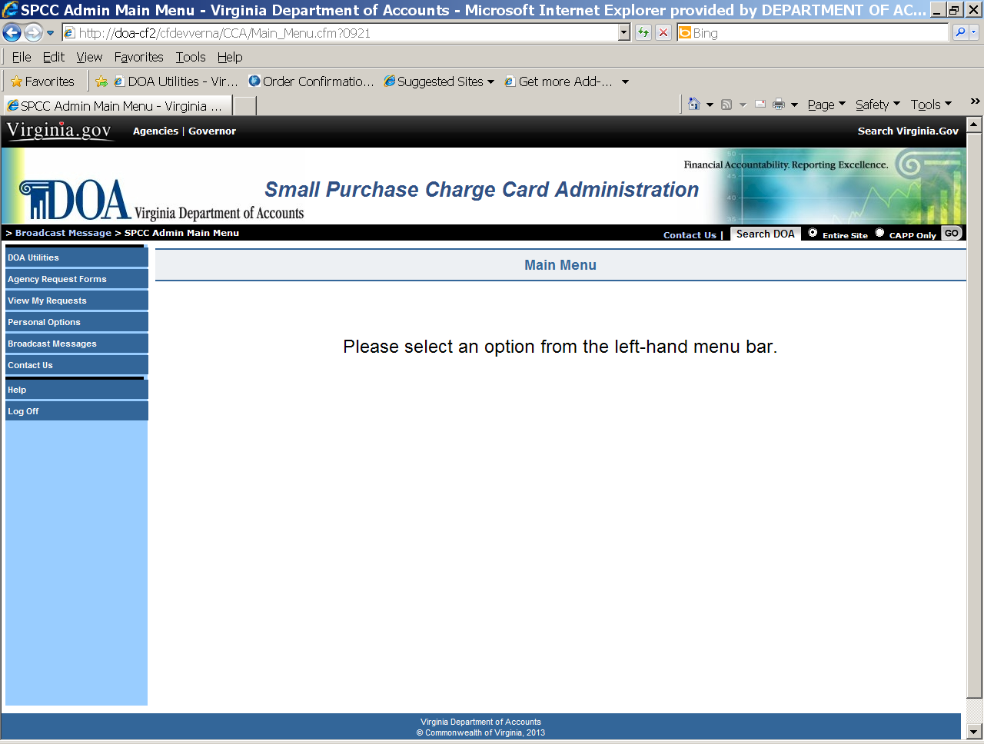

Personal Options Page

View Personal Options | The View Personal Options page allows Charge Card Administration users to view/update existing information regarding their:  - Logon ID  - Password (the actual password is not displayed, but an * indicates it does exist.) Note: Passwords can be changed only one time during a 24 hour period. You must wait 24 hours from the last password update before attempting to change it again.  - Security Challenge Questions and Answers  - Telephone Number  - Email Address  - Hint (to help in remembering current password.)  - Date Password Changed - reflects last date your password was altered.  Select the “Edit Personal Options” button to update the information.

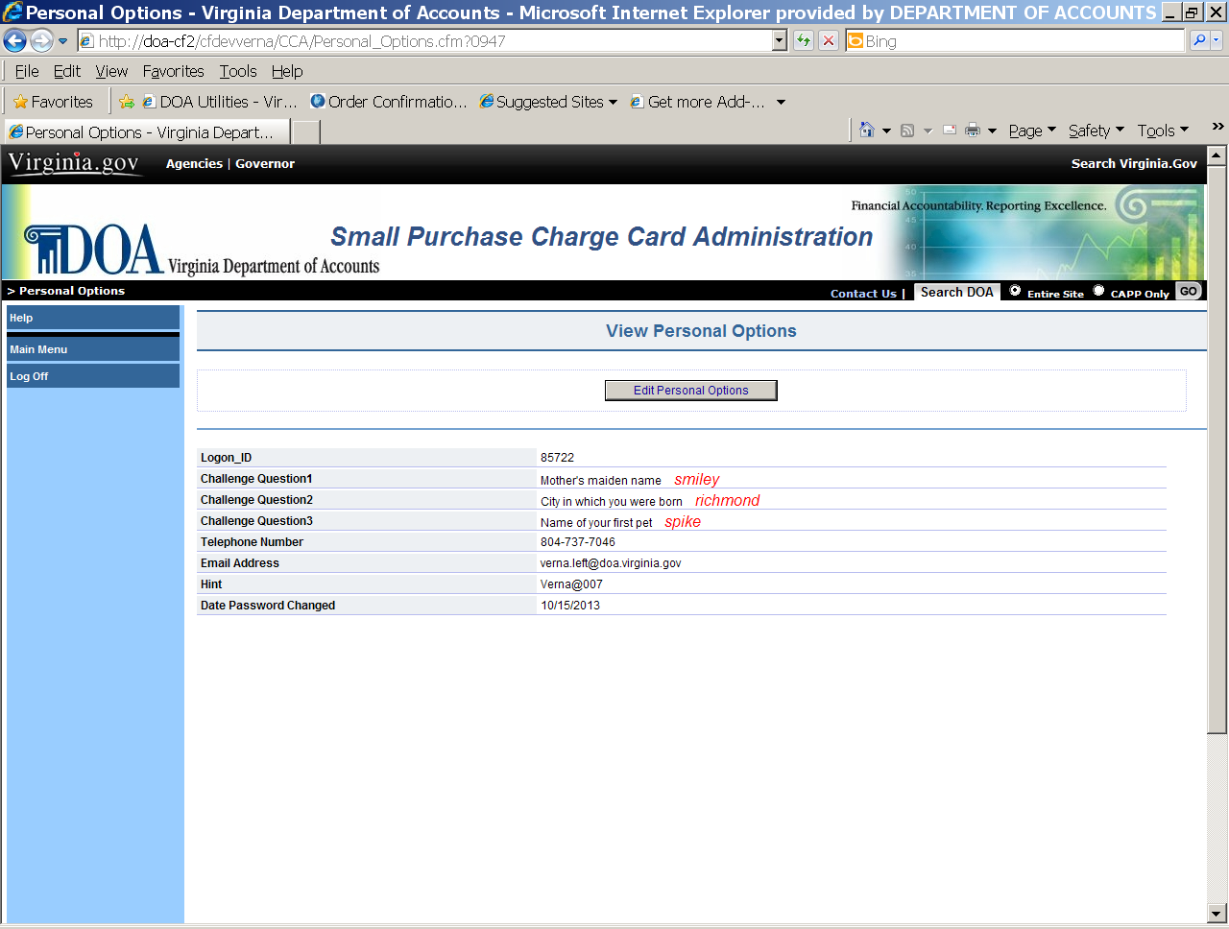

Continued on next page
Personal Options Page, Continued

Edit Personal Options | The Edit Personal Options page provides the Charge Card Administration System user the ability to change the following:  - Password (the actual password is not displayed, but an * is displayed for each password character. Also note that you cannot change your password more than once in a 24 hour period. You must wait 24 hours from the last password update before attempting to change it again.)  - Security Challenge Questions and Answers  - Telephone Number  - Email Address  - Email Address2  - Hint (to help in remembering current password.)  After entering the new information, press the “Accept” button and the information will be displayed on the View Personal Options page. A “record updated” message will appear at the top of the page.  If the information entered is not correct or if the user is not satisfied with the changes, press the Cancel button and the user is returned to the View Personal Options page.

Contact Us

Contact Us | Selecting the Contact Us link will present the opportunity for a user to communicate with DOA. Use this link to ask questions or submit comments about the Charge Card Administration System. A DOA Charge Card Administrator will respond to your email.

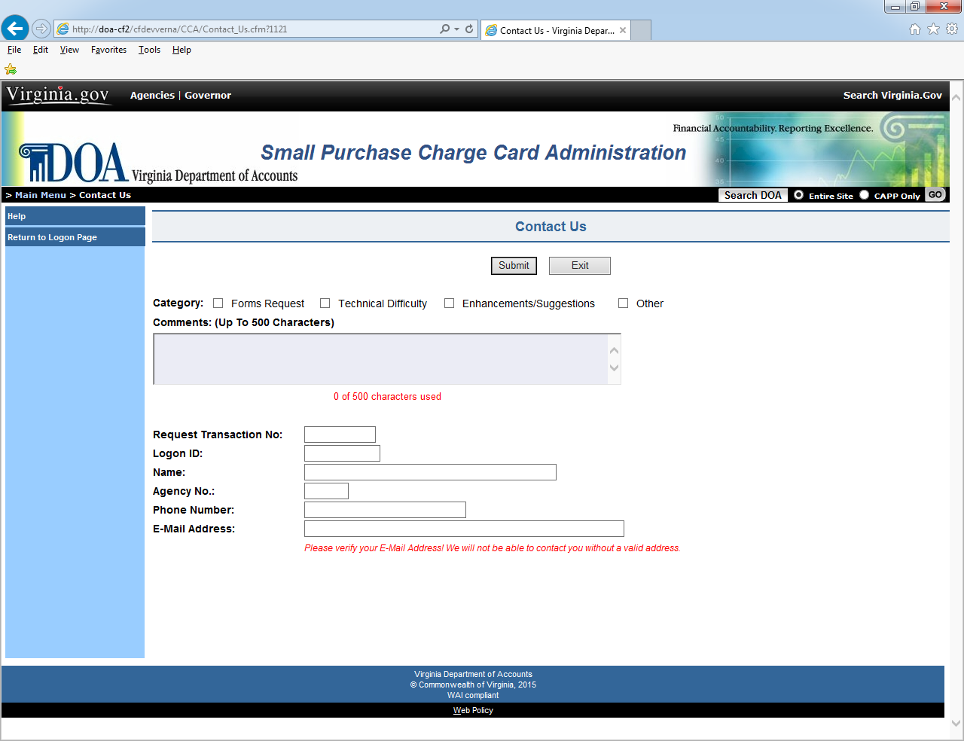

CCA Agency Forms

Form Number Selection | By selecting the Agency Forms option from the Main Menu, the user will be linked to the Charge Card Administration System’s forms page. This page displays the six (6) forms that DOA provides at this time. A brief description of each form is provided on the next page.

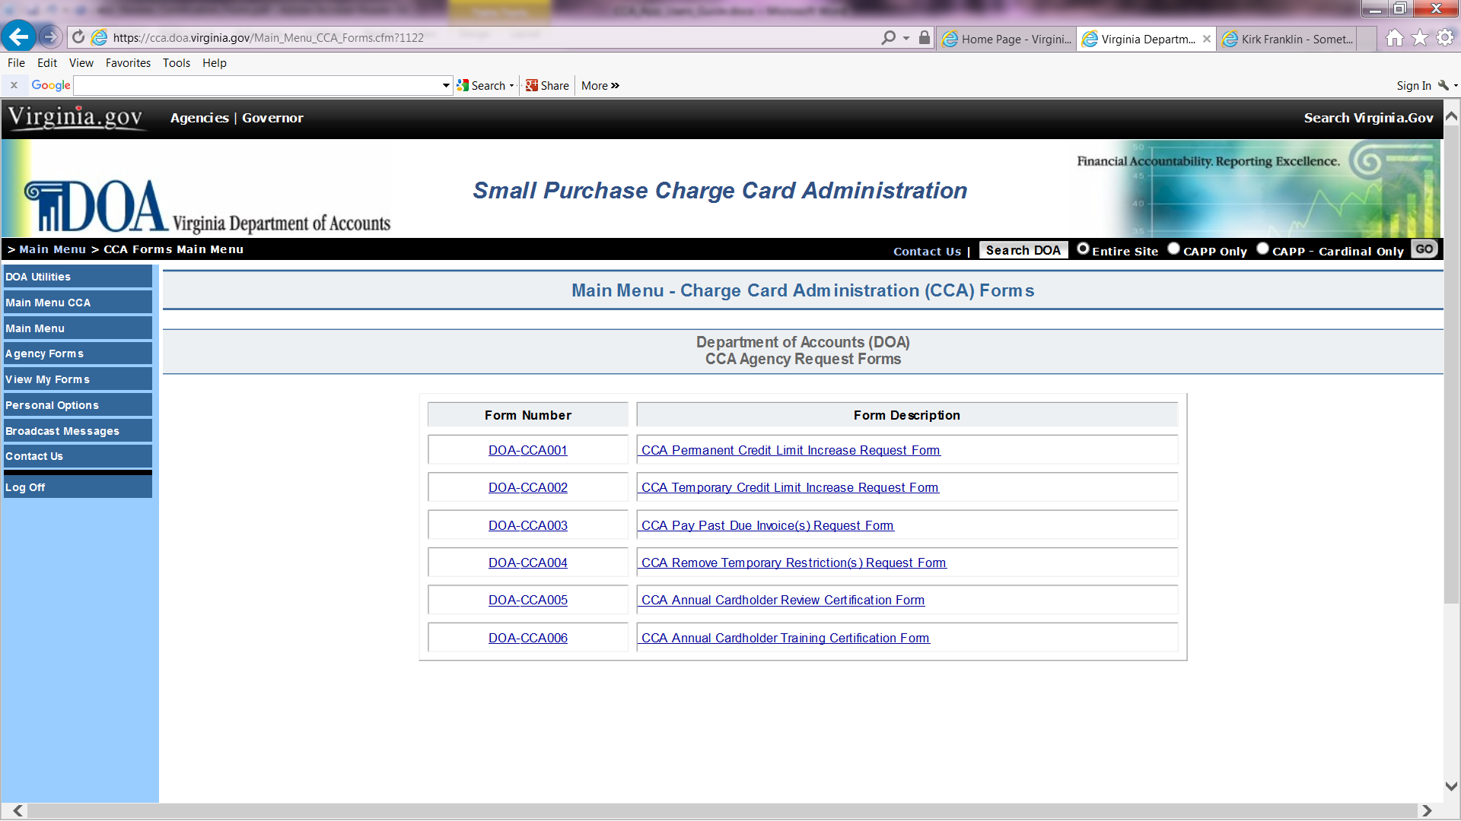

Continued on next page
CCA Agency Forms, Continued

Form Selection (continued) | Description of each form is described below.
 | FORM # | DESCRIPTION
 | CCA001 | Selecting this link will display the DOA Permanent Credit Limit Increase form. This form should be used to request a permanent increase to an agency’s charge card.
 | CCA002 | Selecting this link will display the DOA Temporary Credit Limit Increase form. This form should be used to request a temporary increase to an agency’s charge card.
 | CCA003 | Selecting this link will display the DOA Pay Past Due Invoice(s) form. This form should be used to request a past due invoice payment approval from DOA.
 | CCA004 | Selecting this link will display the DOA Temporary Restriction(s) Removal form. This form should be used to request restrictions be removed from an agency’s charge card.
 | CCA005 | Selecting this link will display the DOA Annual Cardholder Review Certification form. This form should be used to certify that the agency Program Administrator(s) have confirmed all transaction limits, monthly limits, restrictions tables, and transaction volumes were appropriate and coincide with Annual Exceptions submitted to DOA.
 | CCA006 | Selecting this link will display the DOA Annual Cardholder Training Certification form. This form should be used to certify that all cardholders, supervisors/reviewers, and program administrators under your agency purview have completed the necessary annual training for the purchase/travel card programs.
 | Print Forms | Selecting the Printer Friendly link will allow you to Print the selected form.
Continued on next page

CCA Agency Forms, Continued

Form Selection (continued) | Use Form CCA001 – DOA Permanent Credit Limit Increase form to request a permanent card increase.

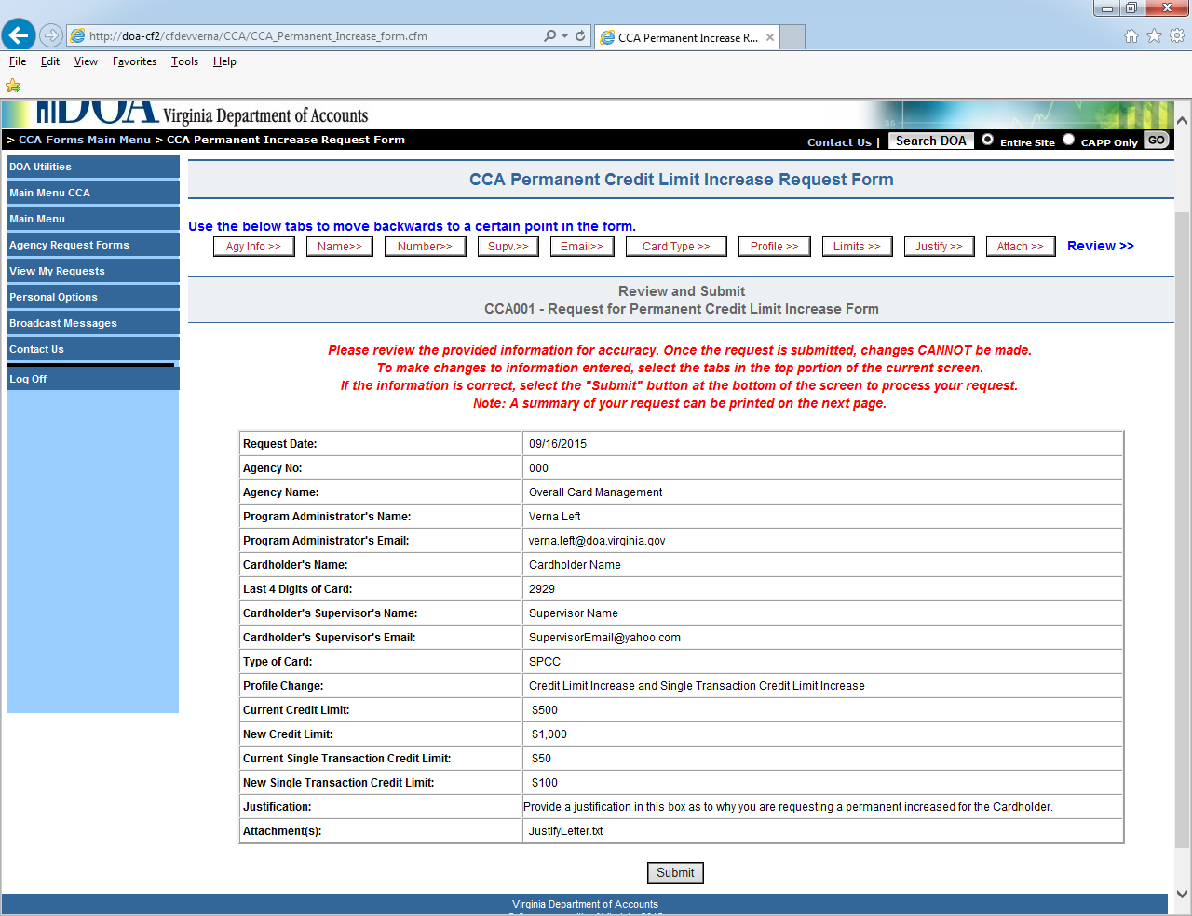

Continued on next page

CCA Agency Forms, Continued

Form Selection (continued) | Use Form CCA002 – DOA Temporary Credit Limit Increase Form to request a temporary card increase.
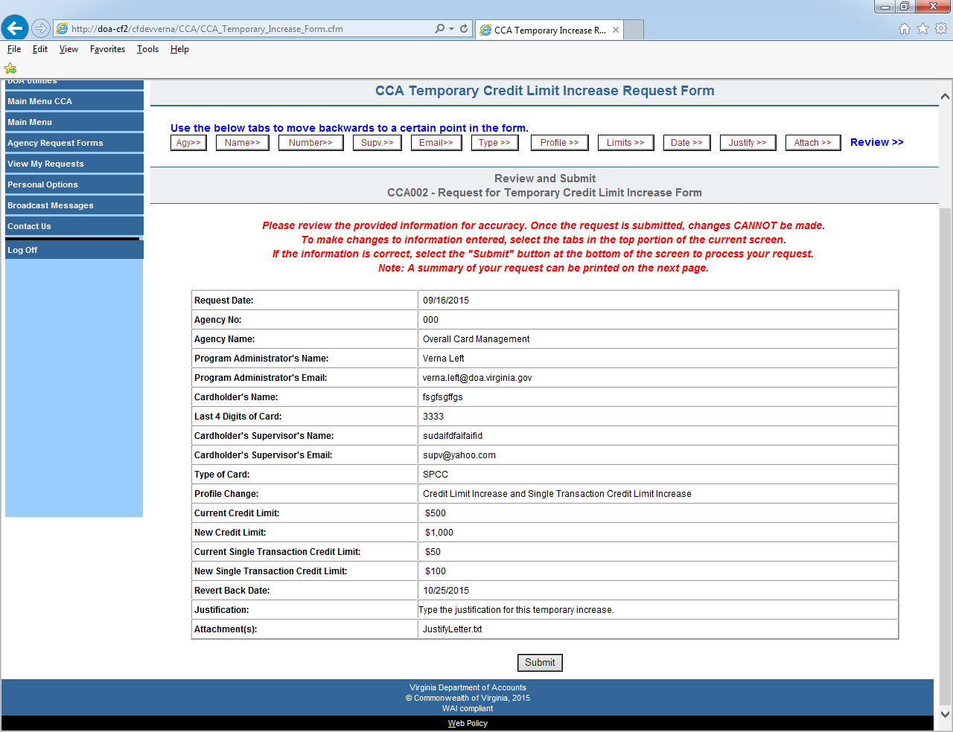
Continued on next page

CCA Agency Forms, Continued

Form Selection (continued) | Use Form CCA003 – DOA Pay Past Due Invoice(s) Form to pay a past due invoice.

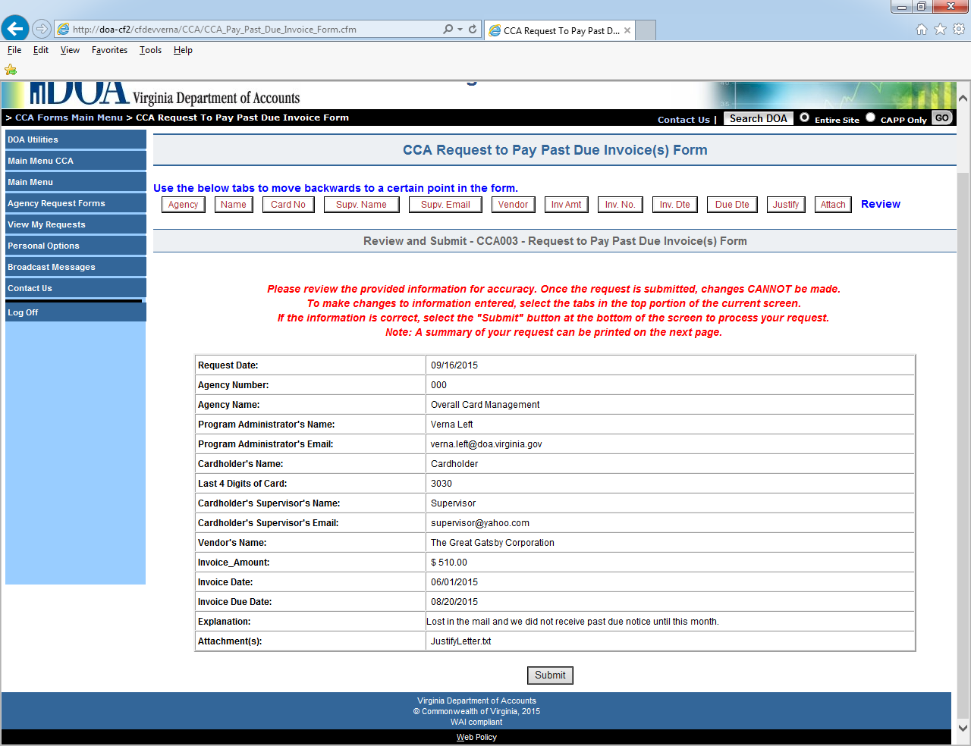

Continued on next page
CCA Agency Forms, Continued

Form Selection (continued) | Use Form CCA004 – DOA Temporary Restriction(s) Removal Form to request a temporary restriction removal from a card.

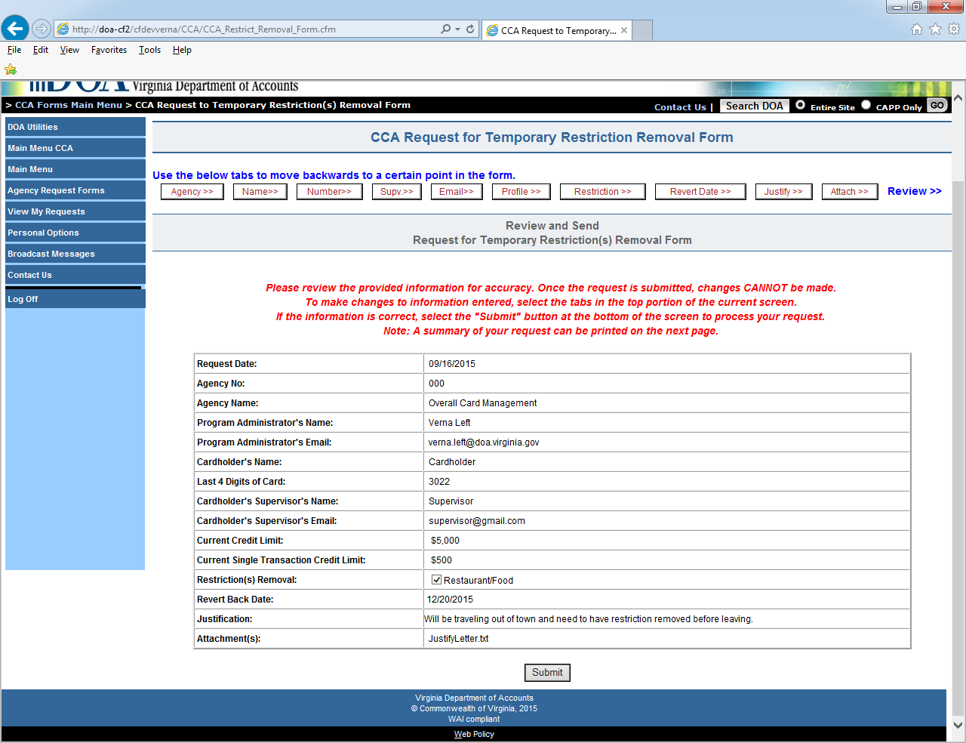

CCA Agency Forms, Continued

Form Selection (continued) | Use Form CCA005 – DOA Annual Cardholder Review Certification. This form should be used to certify that the Program Administrator(s) have confirmed all transaction limits, monthly limits, restrictions tables, and transaction volumes were appropriate and coincide with Annual Exceptions submitted to DOA.

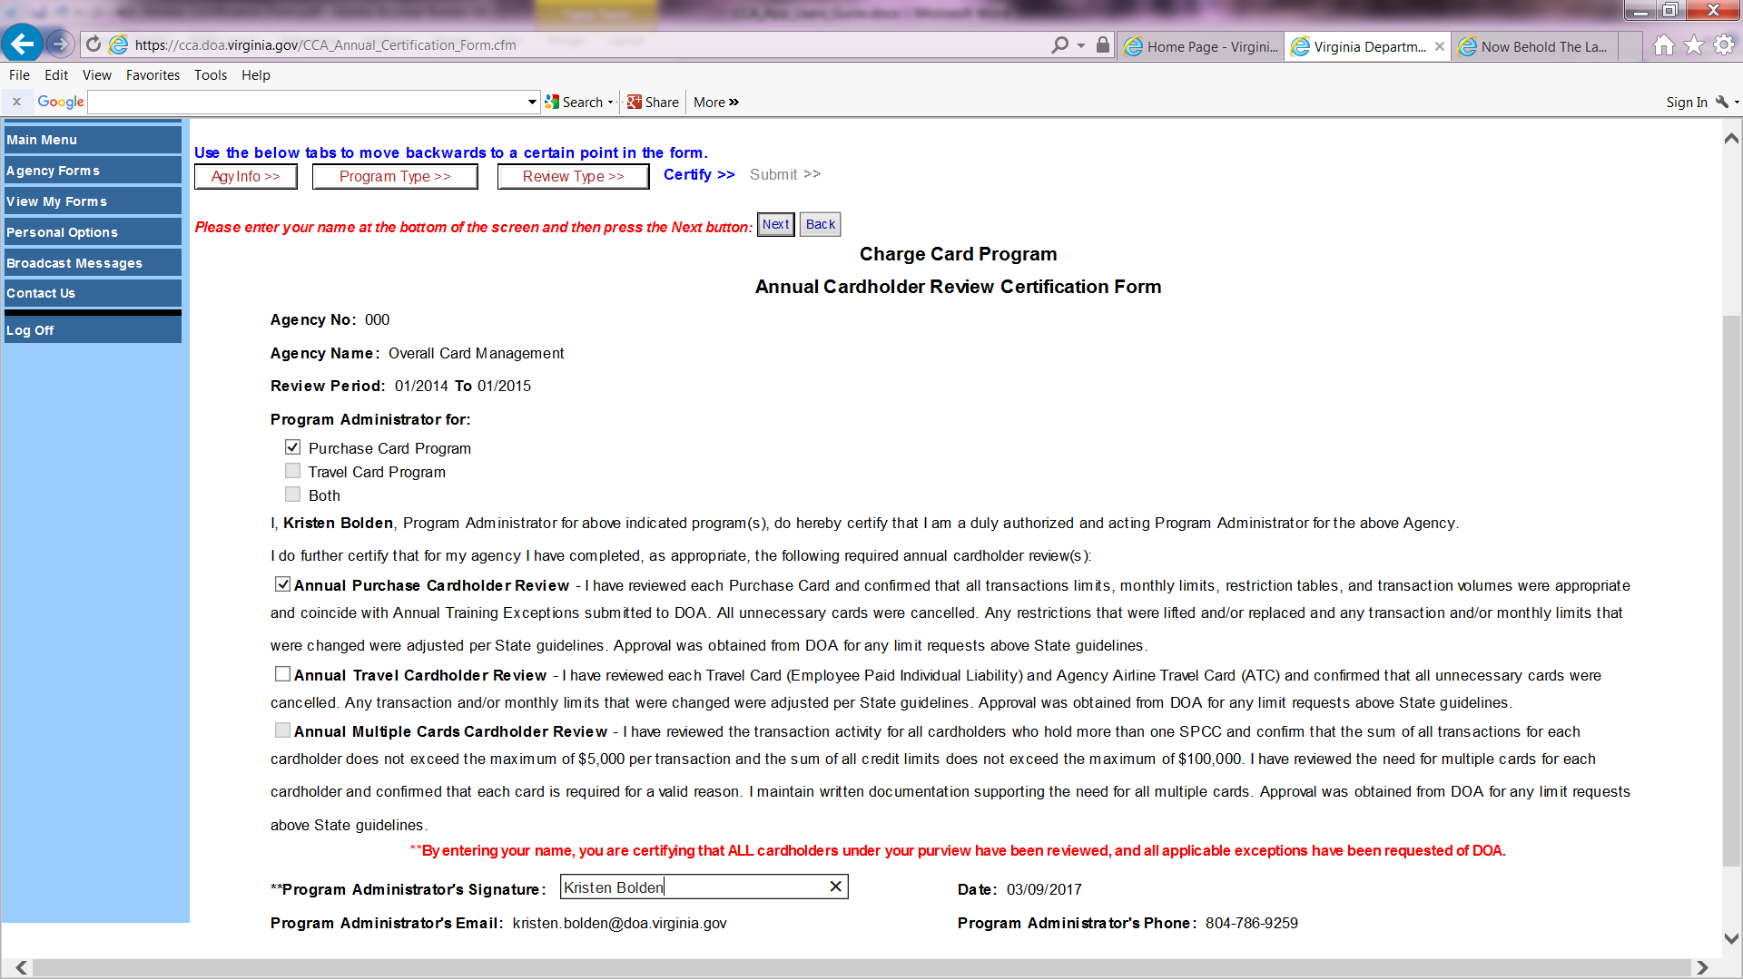

CCA Agency Forms, Continued

Form Selection (continued) | Use Form CCA006 – DOA Annual Training Certification Form. This form should be used to certify that all cardholders, supervisors/reviewers, and program administrators under your agency purview have completed the necessary annual training for the purchase/travel card programs.

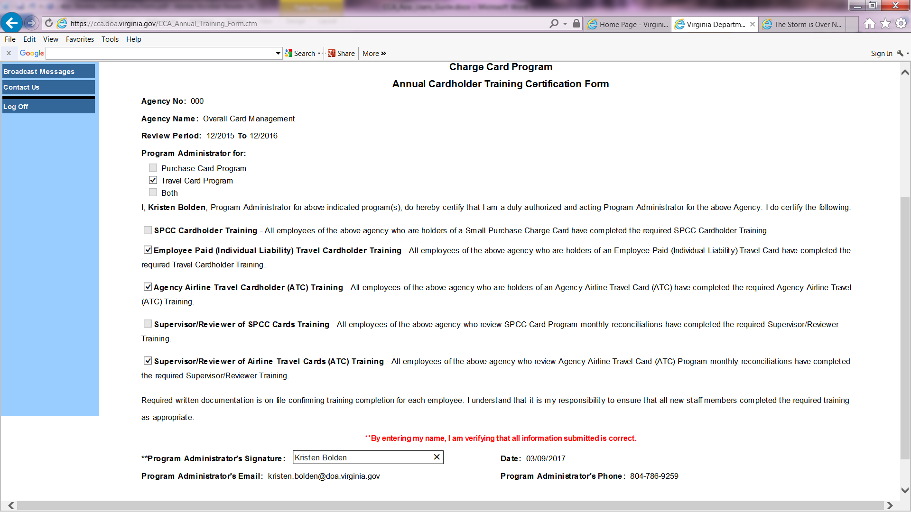

View/Print Agency CCA Forms

View My Forms | Select the “View My Forms” link to view/print your previously submitted CCA Forms or CCA Annual Certification Forms. A summary list the number of requests for each of the forms. Select “Summary Detail” link to display the individual forms.

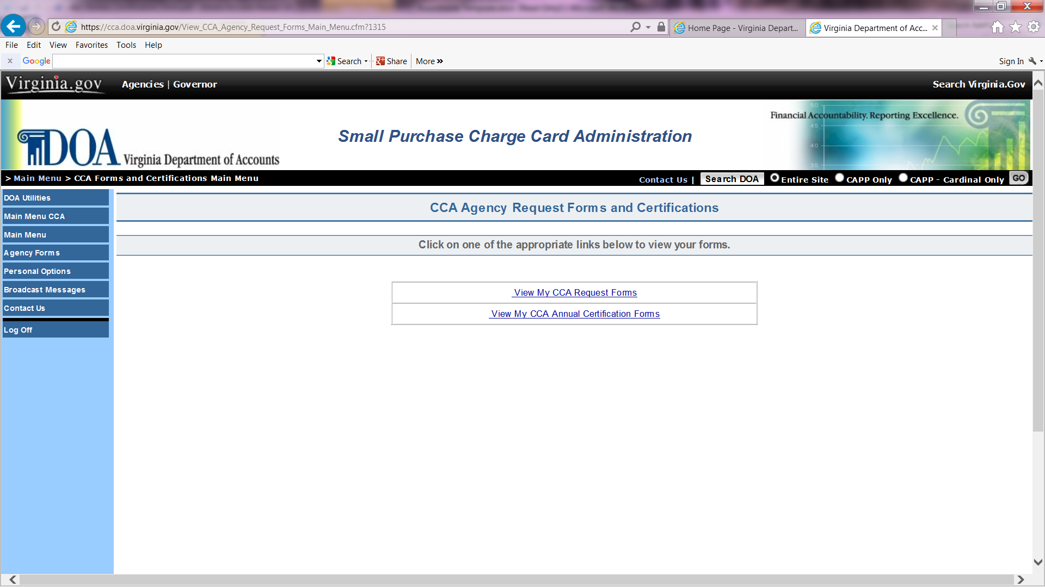

View/Print Agency CCA Forms, Continued

View My Forms,  continued | The following screen is displayed which lists the agency forms by request date and then by agency number. Click on the “Detail” link to display the individual form.

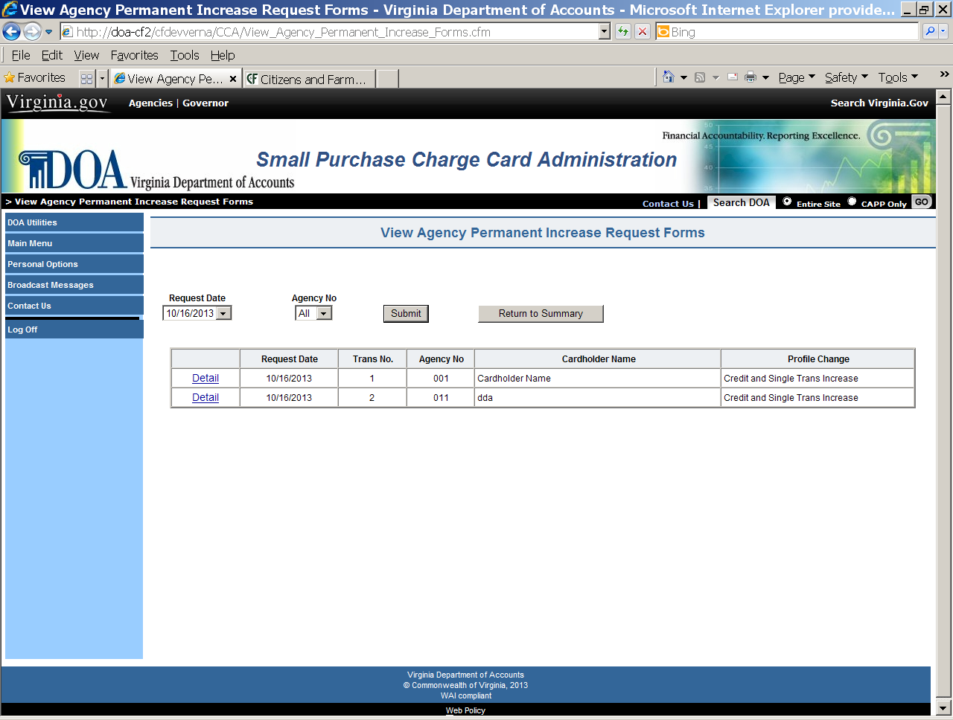

View/Print Agency CCA Forms, Continued

View My Forms,  continued | When the user selects the “Detail” link, the request is displayed. The user can also print a copy of the form from this screen by clicking on the “Printer Friendly Version” link. Selecting the “Return to Detail” button will return you to the previous screen.

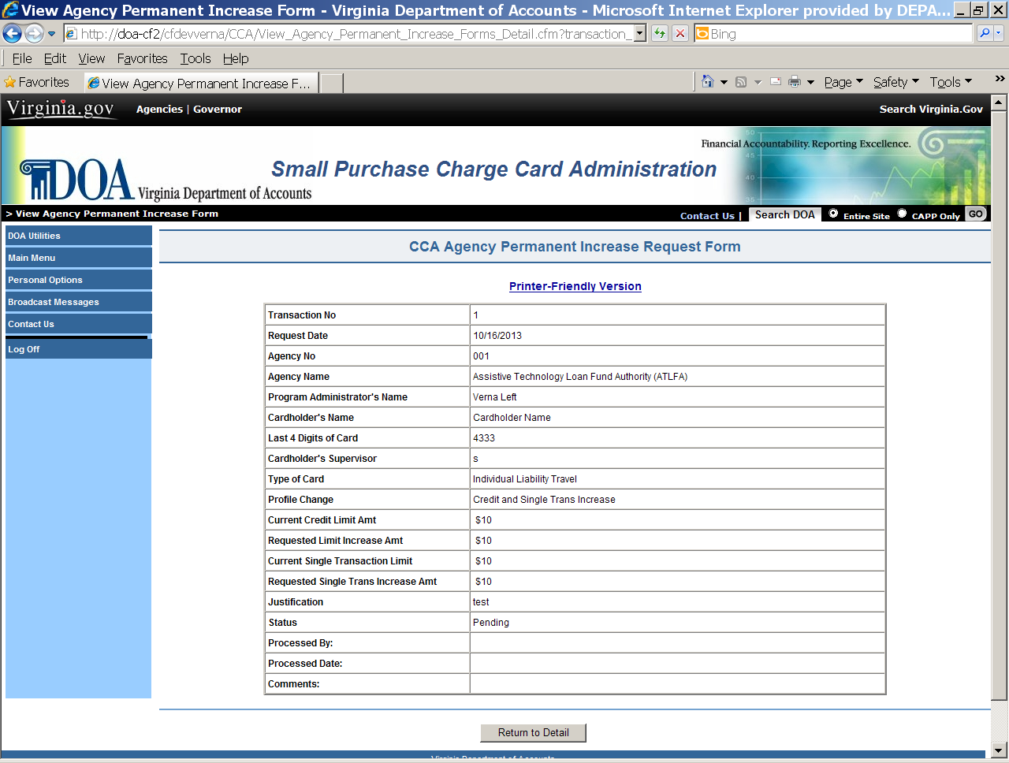

Continued on next page

